You may be familiar with some version of the classical Western “hero’s journey”: a character has an experience, learns something, and is consequently improved. For stories that follow this particular kind of plot structure, there are turning points and scenes that are important to include in order to connect with readers in an emotionally powerful way. As NaNoWriMo participant Derek Murphy points out, “It’s a thousand times easier to map [those scenes] out before you write your book.” This 9-Step structure may help you discover the tentpoles of your story! Read Derek’s blog post here for more details and guidance.

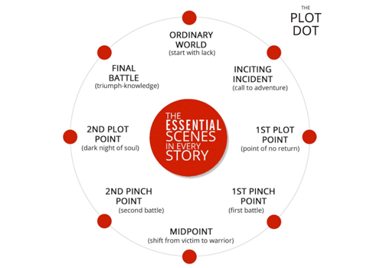

- Ordinary World (start with lack) – Show your main character (MC) and their normal life, including friends, family, job/school. What flaws do they have? What’s missing from their life? What do they want more than anything in the world?

- Inciting Incident (call to adventure) – Boom! Something big changes. Maybe a stranger moves to town, or a family member dies, or there’s an earthquake. Whatever it is, it kicks your story into action. What happens? How does your MC react? Do they accept this call to adventure right away, or try to ignore/deny what’s happening so everything can just go back to normal?

- First Plot Point (point of no return) – Your MC may have tried to avoid the call, but now things are getting weirder/more intense, and they’re forced to make a choice to join the action. Everything changes - there’s no going back now! How does the situation escalate? What forces your MC to choose? How do they feel about it all?

- First Pinch Point (first battle) – Your MC has been exploring their new situation - meeting people, learning new things....and discovering new dangers and tensions. This all leads to the First Pinch Point, which is the first major interaction with the antagonist (in some form). What happens? What will happen if your MC fails to defeat this challenge at the end of the story (the stakes)?

- Midpoint (shift from victim to warrior) – Your MC continues to face new challenges, but they’re on the defense - mostly reacting, waiting, making things worse. Then, halfway through the novel, something happens to shift their perspective and spur them to take action, to stop reacting and start winning, no matter what it takes. What does your MC try when they’re on the defense? What shifts them into offense? What new plans do they make?

- Second Pinch Point (second battle) – Your MC has their second confrontation with the antagonist (in some form). Maybe their plans lead to this, or maybe it was an attack they had to respond to. Either way, this second conflict eventually leads to things being much, much worse than they were before… What happens? What does your MC try to do? How do things get worse?

- Second Plot Point (dark night of the soul) – At this point, everything the MC feared could happen, has happened. They’ve lost the battle (usually because of their flaw or lack of knowledge) and there have been serious consequences. They feel terrible and give up all hope… until something forces them to change their mind, to have a revelation about themselves and their battle. With this new knowledge, they rise up from the ashes. What terrible things have happened? What does your MC do? What revelation do they have, and what new plans do they make?

- Final Battle (triumph-knowledge) – With their new knowledge, and maybe a pep talk from a close friend, your MC goes to battle with their biggest, baddest enemy (whatever that means in your story). Make it dramatic! There’s a back and forth, things seem dark, your MC is going to lose, oh no! And then, victory. What will that final conflict be? What will be the most exciting, tense, drama-filled part of your story?

- Return to Ordinary World – Your MC returns home, changed. They see their old life in a new way. How have they changed? What do they do? How do they feel?

