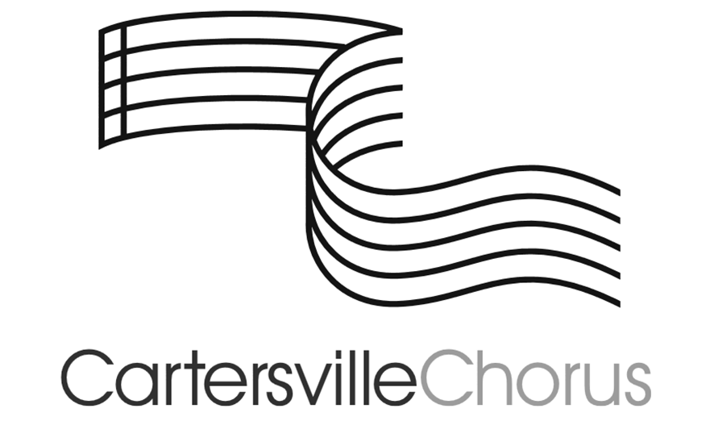

**COURSE SYLLABUS**

Erin Karstensen, Director

Lindsey Montgomery, Principal

ekarstensen@cartersvilleschools.org

770-382-3666

825 Douthit Ferry Rd.

Cartersville, GA 30120

**COURSE DESCRIPTIONS**

**Beginning Chorus/Grade 6** - This performance-based class focuses on learning to use the vocal instrument to create a healthy and pleasing sound. In addition to learning proper vocal production and technique, students learn music reading skills, sight-singing skills, and performance skills. Students sing literature with and without accompaniment in up to three parts. Chorus offers opportunities for students to develop team building and leadership skills. Participation in concert performances outside of regular class hours is required.

**Intermediate Chorus/Grade 7** - This performance-based class focuses on continued demonstration of proper breath control and correct singing posture & technique. Students sing with and without accompaniment and sing literature in up to three parts. Students demonstrate proficiency in sight-reading at the expected competency level and read music with more complex melodies and rhythms. Participation in concert performances outside of regular class hours is required.

**Advanced Chorus/Grade 8** - This performance-based class focuses on continued and consistent demonstration of proper breath control, singing technique and correct singing posture. Students demonstrate open vowel sounds, properly articulated consonants, and appropriate tone quality on more advanced repertoire. Students demonstrate more advanced proficiency in sight-reading at the expected competency level and read music with more complex melodies and rhythms. Participation in concert performances outside of regular class hours is required.

**GRADING**

Grading will break down into the following categories:

* **Rehearsal Skills – *Formative Assessment* – 40%** 
  + Includes posture, breathing and sound production technique, singing with appropriate vocal quality for the age group and level of experience, progression towards music reading/ literacy, understanding and using music vocabulary and symbols, sight singing technique and progression towards accurately performing appropriately leveled sight singing examples, working on learning and memorizing choral literature for concert performance, discussion of music history and background information for pieces we are performing so that we can sing with proper style and performance practice, showing musicality and expression in singing, listening activities, etc.
  + Students who are making an effort to learn and grow in the rehearsal process will not have a problem earning high grades in Chorus class. Grading will never be based on a student’s ability as a singer – rather his or her continued effort towards improvement of musical and choral knowledge and skills.
* **Performance Skills & Other Projects and Assessments – *Summative Assessment* – 60%**
  + Includes concert attendance, performance and professionalism [please refer to the Concert Policies section below for more information regarding expectations for concert performances], skills testing, part checks, etc.
  + Also includes any other assessments or projects that are designed to evaluate a student’s current level of mastery of the choral standards, and the final exam/ post-test.

**CONCERT/ PERFORMANCE POLICIES**

* Choral students are constantly working toward getting music ready for concert performance. The performance experience is invaluable to the music learning process and each voice is important to the whole group’s sound. **It is therefore *required* for students to attend each scheduled concert.**
* Points will be deducted if a student is tardy to a concert, or if the student is not dressed in a proper, clean and performance-ready uniform, or if the student’s behavior is in any way unacceptable for the concert experience.
  + *Students/ Families should communicate with Mrs. Karstensen if any physical or financial assistance is needed with the cost of a uniform.* ***The costs associated with participation in the Cartersville Middle School Chorus should NEVER prohibit anyone from joining or staying with the chorus program if the student wants to take part.***
* Students are not allowed to leave concerts early. Part of the concert experience is listening to the other groups perform.
  + Each concert will be scheduled depending on the musical needs of the choral groups involved. Concert dates are available at the start of the school year, and times and details will be communicated with families as soon as they are available.
  + A very specific Concert Information sheet will be sent home with students, emailed to families and posted online one week prior to each concert performance.
* Inappropriate behavior at a concert will not be tolerated.
* Excused absences from concerts will be dealt with on an individual basis by the director. **A written note or email from a parent or guardian will be required for ANY concert absence.** Excused absences may include, but are not limited to, personal illness, death in the family, or religious reasons. Excused absences from concerts will be the same as excused absences from school. Not having a ride, babysitting, homework, community activities or other non-school-related activities will not be considered valid excuses.
  + Students should communicate with community activity coaches or leaders early and often regarding required concert dates and times and make sure that these leaders know that our performances are a graded part of a class at school.
  + For school activities, students must alert Mrs. Karstensen to any schedule conflict as soon as possible when dates are available, and she will work with coaches etc. to come up with a plan that will work for all involved.
  + Students who are too sick to come to school on the day of a concert should not attend the concert. Students must be at school for half of the school day in order to be eligible to participate in after school activities. Students who have ISS that continues into the next day or OSS on the day of a concert may not perform that night. If a student is in ISS ending on the day of the performance, they may attend.
  + For any absence from a concert, a written assignment will be required to allow for the grade to be made up. Any issues with concert attendance should be discussed with the director and dealt with as early as possible. ***Students will not be given the make-up assignment without written communication from a parent as to why the student missed the concert.*** A student who misses a concert and does not provide written communication from a parent within one week of the concert date detailing the reason for the absence will receive a zero grade for the performance.

**COURSE REQUIREMENTS**

All students are required to participate in full group evening concerts 4 times during the year. 7th and 8th grade singers will also be required to take part in Large Group Performance Evaluation, which is a field trip during the school day where we perform for a panel of judges and receive ratings in March. Any changes or additions to the schedule of required events will be communicated early and often. Support from a student’s family is extremely valuable to their success. **The most important requirement for high achievement in this program is enthusiasm and willingness to work with a team to create an environment that is rooted in encouragement, effort and positivity.**

Students will need a **pencil** (preferably with an eraser) in rehearsal every day. Each student will also need a thin plastic folder with pockets (any color), along with a small supply of notebook paper to keep personal belongings together. This folder will be kept in the Chorus Room. Sheet music and a folder to keep it safe will be provided, and these items will be kept in the Chorus Room. Copies of sheet music will be posted on Schoology to aid students in practicing at home. Singers will benefit from having a water bottle – per school policy it should have a screw-on top and no straw. Students will also bring their single binder that is used for all classes, along with their agenda to class each day.

**GA STANDARDS of EXCELLENCE in CHORAL MUSIC**

**CREATING:**

**1. Generate and conceptualize musical ideas and works.**

a. Improvise rhythmic patterns in duple meter and melodic patterns in major tonality. b. Create basic rhythmic and melodic accompaniments to support other elements of musical performance (e.g. ostinato, bass lines). c. Create physical movements for warm-ups and repertoire to distinguish various musical ideas. d. Set short poetic phrases and texts to music. e. Compose 4 measure melodies in major tonality and duple meter within the range of a fifth, beginning, and ending on tonic.

**2. Organize, develop, and revise musical ideas and works.**

a. Share improvised, composed, and/or arranged pieces. b. Refine improvised or composed pieces using teacher-created criteria.

**PERFORMING:**

**1. Analyze, interpret, and select musical works for presentation.**

a. Utilize a rhythmic and melodic system to read and sing music appropriate to ability. b. Identify basic music vocabulary and symbols representing tempo, meter, dynamics, articulation, and phrasing. c. Notate simple rhythms and melodies from aural examples utilizing a dictation method. d. Read and notate music using available technology.

**2. Develop and refine musical techniques and works for presentation.**

a. Demonstrate appropriate singing posture and breathing techniques. b. Identify basic vocal anatomy. c. Identify aspects of vocal range and tone. d. Identify aspects of vocal change, as reflected in physiological changes affecting range and tone. e. Demonstrate pure vowel sounds and articulate voiced and unvoiced consonants. f. Utilize aural skills to match pitch, improve intonation, and sing with attention to ensemble balance and blend, in one or more vocal parts.

**3. Convey meaning through the presentation of musical works.**

a. Demonstrate technical accuracy and expressive qualities in performance, of a varied repertoire of music. b. Demonstrate and respond to basic conducting patterns and gestures representing tempo, expression, and vocal technique. c. Sing selected music from memory for public performance at least twice per year. d. Exhibit appropriate rehearsal and performance etiquette.

**RESPONDING:**

**1. Perceive, analyze, and interpret meaning in musical works.**

a. Identify and describe components of a musical score (e.g. title, composer, vocal line, measure, system). b. Listen to and describe the elements of a musical performance, including form, voicing, and dynamic contrast. c. Describe the emotions and thoughts that music conveys. d. Discuss how the basic elements of music, including mood, tempo, contrast, and repetition in selected examples (e.g. aural, written, performed), are important to a performance.

**2. Apply criteria to evaluate musical works.**

a. Using self-reflection and peer feedback, listen to and evaluate group music performances with attention to vocal technique, accuracy of pitch and rhythm, diction, and dynamics. b. Reflect on the nature of rehearsal and performance in music through discussion and writing.

**CONNECTING**

**1. Synthesize and relate knowledge and personal experiences to make music.**

a. Discuss how music relates to personal development and enjoyment of life. b. Describe how a musician’s interests, knowledge, and skills determine how they create, perform, and respond to music.

**2. Relate musical ideas and works with societal, cultural, and historical contexts to deepen understanding.**

a. Identify historical and cultural characteristics of a varied repertoire, including world music. b. Demonstrate stylistic characteristics of a varied repertoire, including world music, through vocal performance. c. Identify the historical period, composer, culture, and style of music presented in class. d. Discuss the relationships between the music being studied and world events, history, and culture. e. Discuss and apply appropriate audience etiquette and active listening in selected musical settings.

**COMMUNICATION**

Good communication between the teacher and parents/ families is essential. As a school district, we use the Blackboard program for communication. Your phone numbers and email addresses are pulled automatically into that system from the district’s main information database. Phone messages and emails will only get to you through the information you have given to the school, so please keep that up to date through the front office. I will always send important information through email to make sure it gets where it needs to be. Digital copies of all handouts are also posted on Schoology.

Please don’t ever hesitate to email [preferred] or call me if you have ANY questions or concerns.

**FIELD TRIPS**

Exposure to live musical performance is an irreplicable and effective way to show aspiring performers what amazing heights music can take them to by enriching their perspective and fostering their students’ bourgeoning interest in the art-form. Our standards include proper audience etiquette and learning to critically discuss examples of performances.

Good behavior and grades are required for students who would like to participate in field trips. Any students who has received an office referral or is failing any class may not be allowed to take part in these experiences.

**INSTRUCTIONAL RESOURCES**

The Jenson Sight-Singing Course Volume One, Microsoft Office tools, Sight Reading Factory website

Students will read, study and perform a variety of musical selections from different time periods, genres, cultures and styles throughout the school year.